# Section 1-Analysis

## Problem Definition

People of all ages utilise sorts of digital information in order to destress. Many Year 12 and Year 13 students, after working intense hours during and after school in order to gain high qualifications from the exams they are preparing for utilise video-games as a way to relax and destress themselves. Many middle-aged professionals also utilise video-games in order to destress after long working hours. According to research, high levels of stress can lead to physical symptoms including [headaches](https://www.webmd.com/migraines-headaches/default.htm), [upset stomach](https://www.webmd.com/digestive-disorders/digestive-diseases-nausea-vomiting), elevated [blood pressure](https://www.webmd.com/hypertension-high-blood-pressure/guide/diastolic-and-systolic-blood-pressure-know-your-numbers), [chest pain](https://www.webmd.com/pain-management/guide/whats-causing-my-chest-pain), and problems sleeping. Research suggests that stress also can bring on or worsen certain symptoms or diseases. The problem is that the video-games that are utilised to destress do not necessarily allow the player to destress and do not benefit the player.

A good solution to this problem would be a game that would allow the player to destress and benefit them. For example by improving the players reflexes.Having good reflexes aids performance in sports, exercise, and everyday physical activities like crossing the street, driving and working while poor reflexes can be an underlying reason for faulty movement and injury. Reflexes and reaction time do have a surprisingly large bearing on our ability to avoid any undue injury.Training and challenging your brain can help strengthen the brain and its neural networks. If you frequently train reaction time, the brain's connections will become stronger and healthier, which means that when it comes time to use response time, it will be quicker and require less mental resources.

My solution is to create a gamet that would allow the player to destress and also improve their reflexes.

## My Clientele

My users consist of students between the ages of 15-18 and professionals between the ages of 40-45. They want a game that is straightforward a game that does not require a significant amount of time and investment in order to fully experience it, they objected to the suggestion that the game should have a story mode of sorts. Nonetheless they also want a game that is also challenging to certain extent as they feel that if it was not challenging, they would not be engaged by the game They want the control scheme of the game to be simple as they agree that utilising a complex control scheme would be tedious. They said that they would want to utilise their personal computers in order to play the game. In order to further determine my clients demand I will conduct a survey.

## Current and/or Similar Solutions

## Match Hole

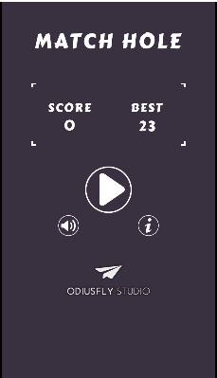

Match Hole is a game in which you have to match a clockwise or anti-clockwise rotating ball onto a randomly determined black ball. When the two ball are on top of each other you click onto the centre of the large circle. If you time this action right you gain a point. If you do not you lose the game, the game then switches to a menu in which it displays your record score and your current score. It then gives you the option to restart or not. The game has a very simple premise’ and does not require a lot of perquisite game knowledge in order to master. Already at the start the white ball moves at a great speed, making it a trickier game than it appears. It is a game that, after playing for a long duration, would improve the reflexes of the person playing the said game. The game also utilises sounds to indicate when you’ve failed or succeeded and has an ambient soundtrack playing in the background. This gives an game a relaxing sense.

## Touch Ball

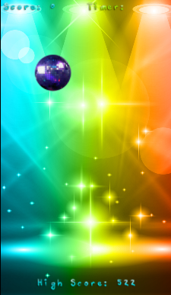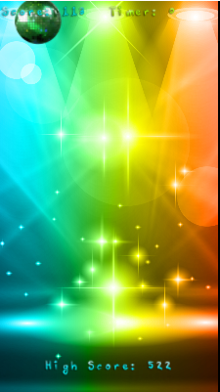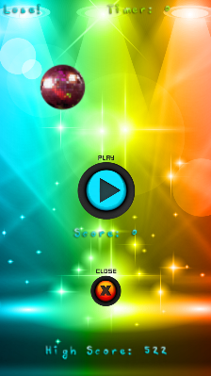

Touch Ball is a game in which a randomly you have to click on a ball before time runs out. The ball’s spawn position is randomly generated. I f you cannot press the ball in a certain amount of time the game over screen appears. In order to indicate that you have successfully pressed the ball the ball turns green. You utilise your mouse cursor as your means of control. Your score increases every time you press the ball however your score depends on how rapidly you press the ball. The game utilises a background soundtrack that I find to be distracting. It utilises a vibrant colour scheme that is engaging. The game allows you to compare your score with your highest score. This game is not complex and is satisfying to play.

Analysing both games I extracted features that I plan to add into the questionnaires that I will provide my clients with. These games showed me that you do not need high quality graphics in order to make a game enjoyable or fun. The simplicity and quality of the mechanics that the game utilises makes it engaging and enjoyable. The games do not contain any sort of story driven element. However, their difficulty does increase as time passes. Both games have a score system. Both games allow the player to improve the reflexes and destress.

## Limitations that I must bear in mind:

I need to take into account of certain clients that might not be able to properly utilise the software. For example, those with certain visual impairments such as colour-blindness might not be able to distinguish certain shape or colours. That means I must optimise my software in order to take into account these limitations. Such optimisations might include features such as high contrast colours and shapes. This would benefit the game in the whole as it would make it more engaging and easier to understand. I will also have to optimise the inputs my game utilises. As it will most likely use peripherals such as a mouse and keyboard, I must minimise the number of inputs required in order to make it an easier game and make it more accessible to those who might have certain motor skill disabilities.

## Questionnaire 1

I plan to interview 8 of my clients by sending them a questionnaire that I have created.

My questions are:

1. Have you ever plaid reflex-oriented games before?
2. How many unique games have you played in this genre before?
3. What features of the games did you dislike?
4. What features of the games did you like?
5. What features would you have wanted to see in those games?
6. What platform would you prefer to play these games on?
7. What do you think is the most important element of a game?

Q1

Yes (8)

Q2

4 (1)

3 (2)

2 (3)

1 (2)

Q3

Design, i.e it felt too childish,bland (3)

Annoying sound design(4)

Pacing issues (1)

Q4

Simplicity (5)

Difficulty (2)

The fact that the game was relaxing (1)

Q5

Nothing more (4)

More intuitive controls (2)

Randomly generated levels (2)

Q6

PC (8)

Q7

Replayability/engagingness (5)

Fun-factor (2)

Interactiveness (1)

## Analysis of questionnaire 1:

I can observe that the entirety of the respondents to my questionnaire are knowledgeable about the type of software that I am aiming to create. I arrived to this conclusion from the information that I gathered from question 1 and question 2. This will help me a great deal throughout development as my interviewees will be able to offer me suggestions as they have considerable knowledge on the subject. I utilised open ended questions like q3, q4 and q5 in order to gain a wide range of information. This will be beneficial to me as it will provide a significant amount of information that will help me build my specification requirements.

This is the list of base specification requirements that I have created from this questionnaire:

-The game mechanic s will not be complex

-The gameplay will be optimised so that it is engaging

-The user shall control the inputs

-The game shall contain a points system, in which a total score will be created.

-The game will be an endless loop, i.e there shall not be any sort of levels, just a continuous stream.

-The games mechanics will revolve around reflex speed.

-The game’s aesthetic will be engaging and not feel too childish.

-The game will end/ a game over menu will appear when the user fails to complete the reflex-oriented task after a certain amount of time

## Questionnaire 2

My questions are:

1. How you would want to control the character?
2. Would you want music and if so what type?
3. What would you want the overall aesthetic to be like?
4. Would you want abilities or power-ups to be included into the game?
5. Would you want an inventory system to be implemented into the game?
6. Would you want the enemies to have a health bar?
7. Would you want difficulty levels to be implemented into the game?
8. Would you want the difficulty to increase over time?
9. What would you want the window size to be?

Q1

Mouse (5)

Keyboard(4)

Q2

No(6)

Yes(2)

--ambient

--disco

Q3

Retro (3)

Simplistic (2)

Futuristic (1)

Arcade (1)

Cant comment (1)

Q4

No(6)

Yes(2)

Q5

No(8)

Q6

No(4)

Don’t know how it would fit with the game (2)

Yes (2)

Q7

Yes(3)

No(5)

Q8

Yes(4)

No(4)

Q9

1000x1000(2)

Smaller than the size of my screen (4)

1920x1080p(2)

## Analysis of questionnaire 2:

This questionnaire gave me a wealth of information regarding the wants of my clients regarding design and gameplay elements. The majority of my clients rejected the suggestion that the game should contain any music. Regarding the aesthetic, retro was the most popular one. The majority of my interviewees did not want abilities, an inventory system and health bar systems as the believed that they would unnecessarily overcomplicate the game and make it tedious. They disagreed with the notion of difficulty settings or rise as they stated that it would be unnecessary. They were not able to give proper responses to the screen size, however the majority of them stated that it should be smaller than the resolution of their own screens.

In order to improve the aesthetic of the game and add a unique mechanic, the game will be based around a radar, this radar will detect the enemies, the player will then have to lock and then destroy the target in quick succession

## Final List of Specifications and Requirements.

-The window size shall be 1000x1000

-User inputs will be managed by the mouse and keyboard

-The user will move around an object that will be used to destroy the enemy

-The game will have a score system, in which it will record the score achieved by the user

-After the enemies cross a certain point in the game a game over screen will come out

-The goal of the player will be to complete two separate tasks in quick succession in order to destroy the enemy

-The games mechanics will revolve around reflex speed.

-The game’s aesthetic will be engaging and not feel too childish.

-When the enemy is destroyed the player will be awarded points as the score would increase

-The game over screen will display the score achieved by the user.

-The enemies will spawn in random order at pre-determined locations.

-The radar will detect the moving enemies

-The player shall control a cursor that will move onto the targets

-Then the player shall use the keyboard to lock and destroy the target

## Software and Hardware Requirements

Windows 7 and above

-The OS required to run pygame

1.5 GHZ+ processor

-min spec for pygame

4GB RAM

- min spec for pygame

3GB HDD or SSD space

- min spec for pygame

Pygame must be installed on the User’s computer